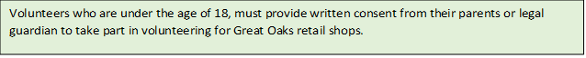

**PARENTAL CONSENT FOR VOLUNTEERING FOR THOSE UNDER THE AGE OF 18**

The following declaration must be signed for by the volunteer’s parent or legal guardian: -

I hereby give consent for my son/daughter/ward (delete as appropriate) to volunteer for Great Oaks retail shops

Full name of young volunteer:

Date of Birth:

Home address:

Email address:

Signature of parent/legal guardian:

Printed name of parent /legal guardian:

Relationship to child:

Emergency Tel No.(s):

Any additional information that you would like us to be aware of:

Date

Initials

**Office Use**

Risk Assessment completed

Information Checked

**Great Oaks will conduct an individual Retail risk assessment to ensure the safety of all under 18’s that volunteer within their shops.**

**UNDER 18’S PHOTOGRAPHIC CONSENT FROM PARENT/LEGAL GUARDIAN**

I can confirm I am the parent/legal guardian of the child named above and I agree to my son/daughter/ward’s image being used by Great Oaks for the purpose of promoting Great oaks.

Signature of parent/legal guardian:

Date: