GREAT OAKS - EASY READ COMPLAINTS POLICY


Complaints


Making a complaint means speaking up about something you do not

like or something you are not happy with. It can be about anything that

our services do or it might be about someone who works for us.

This could be done by
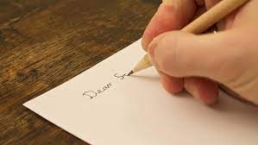 Writing to us
Great Oaks Hospice
The Gorse
Coleford
Gloucestershire
GL16 8QE
 Calling us 01594 811910

 Emailing us Clerical@great-oaks.org.uk


Tell someone else who can complain on your behalf, like a family member, friend or advocate if needed


Someone from the Hospice will write you a letter within 5 days so that you know your complaint has been received.


We will also let you know the name of the person who will investigate your complaint, and how to contact them.


Your complaint will be looked into fully.

The person dealing with your complaint may come and talk to you if they need more information.
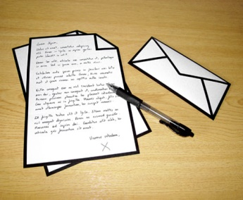


We will aim to let you know the outcome of your complaint with 28 days.


We will tell you what has been done about your concerns and how we will make things better.

