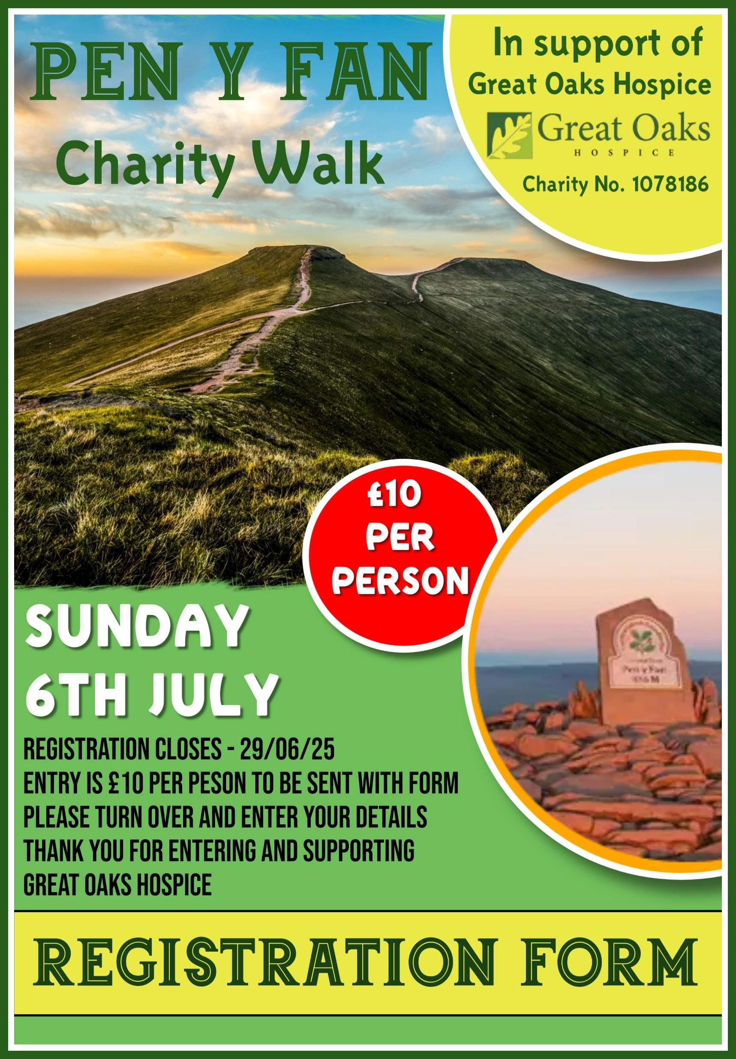

**Registration Form for Sunday 6th July 2025**

The Pen Y Fan Circular Sponsored Walk is for ages 14+ and following a set route up and down Pen Y Fan Circular, which includes Tommy’s obelisk. Marshalls will lead and follow all walkers.

You must read the

Risk Assessment before starting and sign to say you take responsibility for your own health & are fit and able to do the walk. First Aiders will be present. Registration and

Safety information at **10AM**. (You must attend) The walk will start at **10.30AM**, weather permitting.

In the event of adverse weather conditions, you will be notified if it is cancelled.

***The walk starts at Pont ar daf car park (Grid Ref 988199, Postcode LD3 8NL****),* ***on the A470 between Brecon & Merthyr Tydfil.***

Name:

Address:

Telephone:

E-mail:

**Parental/Guardian Consent (each 14-18 years old must be accompanied by an adult)**

Name:

Relationship:

Signature to confirm consent for the above 14–18-year-old to walk:

**Emergency Contact**

Name:

Relationship: Contact No:

There is no minimum sponsorship amount required to take part, but all monies collected will be gratefully received by the Hospice. Wear suitable clothing and footwear for a

hill walk; dress accordingly & bring with you everything you may need for the walk.

(drinks, medications etc.)

Return form to: Great Oaks Hospice, The Gorse, Coleford, GL1 6 8QE.

**I agree to take responsibility for my own health and welfare during the walk and agree that I am fit enough to take part in the Pen Y Fan walk.**

**I have read the Risk Assessment.**

**Signature:**

|  |
| --- |
|  |

**£10 Payment enclosed (please tick)**

**Please read the Risk Assessment prior to the walk.**

|  |  |  |  |
| --- | --- | --- | --- |
| **Identified Hazards** | **Who is at risk?** | **Example Causes** | **Control Measures** |
| Personal Injury e. g., Slips,  Cuts, Twisted  Ankles, Spinal  Injuries,  Broken Bones Heart Attacks Strokes, loss of  communication | All  Participants/Group  Leaders | Tripping over rocks. Tiredness leading to falling over more easily. Descending steep routes.  Back injuries caused by lifting heavy rucksacks  Insect bites  Own ill health  Limited visibility | Organisers to provide health and safety briefing to prevent injuries where appropriate prior to walk.  Marshalls to carry first aid kit.  Walkers will wear head torches or carry a torch. Walk in pairs if able to. First Aid and emergency procedure training to be provided prior to walk. Consent form signed prior to walk. Walkers to take responsibility for own health and fitness to take part.  (Own limitations and health  conditions.)  Marshall at front and rear of walking group.  Walker must carry a torch or wear a head torch and carry a fully charged mobile phone. |
| Walking in adverse weather and night/day conditions | All  Participants/Group  Leaders | Cold, wet windy days or extreme heat days resulting in:  Sunburn  Heatstroke  (Hyperthermia/  Hypothermia)  Frostbite  Colder weather during the dark, warmer weather after sunrise. | Obtain weather forecast and plan accordingly for early morning walking.  Appropriate clothing to be worn / carried.  Appropriate amounts / type of food and drink should be carried dependent on weather conditions, terrain etc.  Use of sun cream to be encouraged if required.  Appropriate group safety equipment to be carried.  Head wear/hats to be worn. Use of sun cream to be encouraged.  Wear gloves in colder weather |
| Ticks & Lyme’s Disease | All  Participants/Group  Leaders | Sitting in long grass  Walking through thick undergrowth | Appropriate safety briefing given to group beforehand  First aiders in attendance. |
| Participants not turning up on time or returning at the end | All  Participants/Group  Leaders | Low cloud  Injury  Poor navigation | Marshalls to hand-out route details, including return check in details. Contact details and emergency contact details taken.  Marshalls on the route in ratio to the number of walkers.  **Anyone who does not arrive at the arranged start time and who misses the safety talk, and the roll call cannot be included in the organised walk. If you have not checked in you will not be monitored by Great Oaks Marshalls on the route.** |
| **Identified Hazards** | **Who is at risk?** | **Example Causes** | **Control Measures** |
|  |  |  | Walkers must not lap the lead Marshall so that they can be accounted for. They must be ticked off the roll call list at the end. One Marshall must always remain at the rear of the walking group.  Marshalls will return to the route to look for walkers who do not return, if safe to do so, and will inform the emergency services immediately. Marshalls to have all walkers contact details and emergency contact details with them.    Any walkers who need to carry emergency medication with them please inform the Marshalls prior to the walk and inform who you are walking with.    **Role of a Marshall: to supervise the safety of others on the organised walk. To have prior experience of walking the route and to have experience of being a Marshall on other organised walks. To carry a fully charged mobile phone and first aid kit and to co-ordinate the walk with each other.** |

I

***You must bring fluids with you, a fully charged mobile phone and wear suitable walking gear and footwear.***